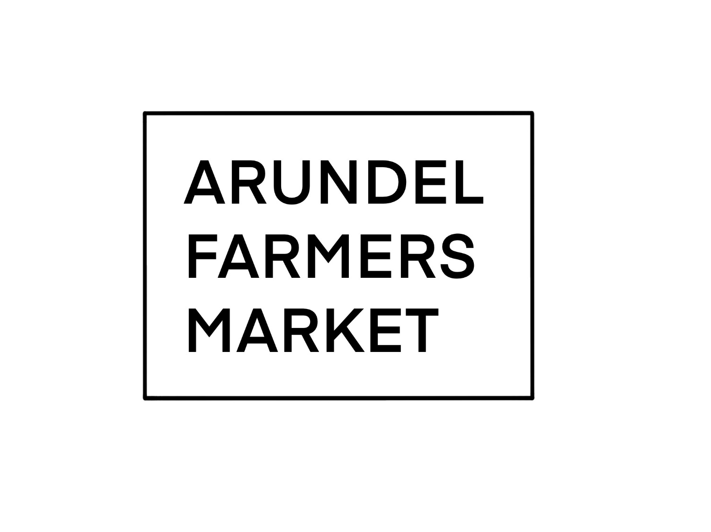

**CRITERIA, GUIDANCE & APPLICATION FORM**

**2025/2026**

**ARUNDEL MARKETS CRITERIA & GUIDANCE**

Arundel Farmers & Artisan Markets (AFM) offer producers a retail outlet to sell direct to the public. The long-term aims of the Market are to promote healthy eating, environmentally friendly and sustainable food production, as well as encouraging creative skills in arts and crafts using locally sourced materials.

**Locally Produced:**

The defined area is a distance of 40 miles from the market site. Producers from further afield may attend the market if there is no suitable local producer of a given product; this is at the organisers’ discretion. The organisers may change the radius of the market to accommodate specifics needs; No producer should come from beyond 100 miles of the market.

**Category 1 – Primary Produce:**

* Includes eggs, fruit, vegetables, herbs, meats, dairy products, bakery products, honey and bee products, wine, cider, beer, fruit juices, flowers and plants.
* Plants may include planted baskets if wholly grown and arranged by producer.
* Exceptions may be made for products which are not available locally or to respond to customer demand
* The organisers will permit the sale of locally caught fish, seafood or farmed fish.
* All animals to be kept under humane conditions and producers free from prosecution or threat of prosecution
* The stall should be operated by someone directly involved in production, not just in other aspects of the producer’s business. This ensures the operator of the stall will have specialist knowledge and can advise consumers about the details of the product.

**Category 2 – Secondary Produce: Handmade consumable products**

* Anyone processing produce, or adding value is a secondary producer.
* Includes ready-made meals, beer (Brewer), condiments, confectionary, preserves, cakes and desserts whose principal ingredients are from primary produce from category 1.
* All processed goods must contain at least one ingredient of origin from within the defined local area (**not merely bought locally**) The minimum local ingredient is 10% of each product.

**Category 3 – Handmade craft items**

* Only products hand made locally, preferably with locally sourced materials. However, we understand some materials will not be available locally. The products must be manufactured within 40 miles of Arundel.
* Arts and crafts items could include Paintings, Prints, Cards and stationery, jewellery, woodwork; toys and homeware, clothing and knitwear (hats, scarves etc.), ceramics, leatherwork, candles.
* Guest traders may be allowed up to 3 times a year to fulfill a gap in craft products that are not available locally and to support the market goals of a diverse and wide product offering. This will be at the organisers’ discretion.
* These traders may be able to sell products that are ‘in keeping’ with the market aesthetic but should be designed and manufactured within the UK and be based within a 100 miles radius of Arundel. These criteria are at the event organizer’s discretion.

**Principal Producer:**

* Someone directly involved in production shall operate the stall; or someone employed by the producer who has significant knowledge of production method.

**Collaborative Groups:**

* Producer’s cooperatives and community associations such as local allotment societies or WI groups may be agreed as principal producers on a case-by-case basis by the organisers.
* Small-scale producers, either primary or secondary may come together as a collaborative group. The criteria for both primary and secondary produce will apply.

**In addition:**

* Each producer retains ownership of stock. (**No stock bought in**)
* Produce must be clearly labelled with producer’s name and place of business in addition to legal labelling requirements.
* At least one producer in the collective must be selling at all times.
* Each producer of the collective to complete and sign application form and provide evidence of insurance.

**Charity and non-profit stalls:**

* A limited number of charity and non-profit stalls will be allowed at each market at the discretion of the Market Manager, with one free charity stall per month. These organisations must be based within 40 miles of Arundel.
* Further stalls to be charged at the community rate of £33. A suitable level of PLI cover, based on the goods and services of the stallholder, to be agreed with the Market Manager. Applications should be made on the application form below, with **pre-application enquiries to** [**townevents@arundeltowncouncil.gov.uk**](mailto:townevents@arundeltowncouncil.gov.uk) **01903 882954 option 3.**

**General:**

* Only certified organic producers can trade under the “organic” label and must display organic.

Certification must be from an accredited body.

* No genetically modified (GM) produce or produce knowingly containing GM ingredients can be sold at this market.
* No additives or artificial colouring in any product.
* No processed fats (such as Hydrogenated fats) to be used in any product.
* This market does not permit / support the purchasing / repackaging selling on of finished goods.

**Policy and Information**

* The producers should be able to provide information about their production methods.
* Producers must display business name and address clearly and provide information about production practices.
* Products must be traceable.
* Producers may be required to provide information about their trade for the effects of evaluating the impact of the market and for the planning of future markets.

**Legal and Regulations: Food Safety, Trading Standards and Insurance etc.**

* You are responsible for complying with all laws and regulations regarding the production, preparation, labelling, display, storage and sale of goods and also the relevant Trading Standards legislation.
* Food must be marked and priced according to legal requirements.
* We require all food traders to have a minimum current (within the last 3 years) Food Hygiene Rating of 4 – Good.
* Stallholders are required to have £5m Public Liability Insurance cover, £5m Product Liability Insurance cover and an appropriate level (normally £10m) of Employers Liability Insurance employee and products liability insurance. Photocopies of relevant certificates etc. should accompany your application. Proof of renewal of insurance will also be required at the appropriate time.
* We wish to encourage high standards of food safety and best practice and would encourage traders to use chillers and freezers to display their products wherever possible. Sneeze guards are also a welcome addition, along with frozen chill packs under produce where necessary (especially summer months).
* Stallholders who are purveying food are required to have obtained the relevant level of food hygiene certification.
* Trading Standards and Environmental Health Officers will make unannounced visits to farmers and artisan markets.

**Alcohol and game:**

* Special licensing arrangements must be made in order to sell alcoholic beverages or game at a market.
* Arundel Town Council will organise the TEN for the market days.
* Sellers of game must provide an up to date game dealers license authorising the dealing, processing, and selling of game.

**Applications:**

* The organisers will consider all applications however they reserve the right to refuse any application without giving a reason.
* Normally no more than a maximum of 3 producers in each category of produce will be allowed.
* Only produce included on the initial application will be allowed, any additional produce or product will need completion of a further application form and agreement by the organisers before being sold.

**Verification:**

* The organisers (or their chosen representative) may make scheduled visits to places of production to verify compliance with the “Producer-Only” rule.
* Complaints of suspected violations of the “Producer-Only” rule must be submitted in writing to the organisers and signed. Refusal to permit reasonable visits to a site will result in suspension or expulsion from the market.
* Meat producers may be required to produce copies of slaughter certificates and animal movement records to satisfy trace-ability legislation and the “producer-only” rule.

**General Matters**

* Stallholders must be set up and ready to commence trading by 9am and must then continue trading until the market closes at 1pm.
* Stallholders should not close down (unless sold out) during market trading hours (meat sellers without refrigeration are exempt).
* Stall areas should be kept clean and tidy.
* Stallholders are responsible for their own security.
* A no smoking policy applies to all stallholders (includes vaping).
* Allocation of stalls is solely the responsibility of the Market Manager.
* Stallholders required to use the stalls provided by the market.
* Stallholders are responsible for clearing up their stall area, picking up and bagging rubbish and sweeping the area. It is extremely important that stall areas are left clean and free from rubbish at the end of the market.   
  **YOU MUST TAKE YOUR RUBBISH AWAY AT THE END OF THE MARKET.**
* The organisers reserve the right to remove side and back sheets or to close the market early without prior notice or cancel the market in the event of adverse weather conditions.

**ORGANISATION AND PROTOCOL**

* The market is held on the 3rd Saturday of every month, Arundel Farmers’ & Artisan Market will be situated in Arundel Town Centre and Quayside.
* The market is open to the public from 9am to 1pm.   
  Stallholders must be ready to trade before the market opens.
* Vehicles will be able to unload from 7.30am until 8.30am
* Once unloaded, vehicles must be parked legally. If you use a car park (a valid ticket MUST be purchased).
* In the interests of public safety, no vehicle movements will be allowed between 8.30am and 1pm.
* Vehicles will be able to re-load after 1pm

**VEHICLES and TRAILERS**

* Due to size restrictions special arrangements must be made with the organisers if traders wish to sell direct from their own vehicle or trailer.

**PRICING**

|  |  |  |  |
| --- | --- | --- | --- |
|  | **SINGLE PITCH** | **Monthly equivalent** | **Saving vs 1 month (approx.)** |
| **Monthly Payment** | **£49.50** | **£49.50** | **0%** |
| **3 months in advance\*** | **£141.00** | **£47.00** | **5%** |
| **6 months in advance\*** | **£267.00** | **£44.50** | **10%** |
| **12 months in advance\*** | **£489.60** | **£42.00** | **15%** |
|  | **DOUBLE PITCH** | **Monthly equivalent** | **Saving vs 1 month (approx.)** |
| **Monthly Payment** | **£93.00** | **£93.00** | **0%** |
| **3 months in advance\*** | **£247.50** | **£82.50** | **11%** |
| **6 months in advance\*** | **£464.10** | **£77.35** | **16.50%** |
| **12 months in advance\*** | **£866.40** | **£72.20** | **22%** |
| *All payments must be electronic and received by the Monday before the Farmers Market falls.  **Late payment will be subject to a £5 surcharge to reflect the extra administration involved.** | | | |

* **A standard pitch varies between 2m and 2.5m, please contact the organiser to clarify the size of your stall.**
* Fee rates for multiple pitches / pitches of non-standard size are subject to negotiation with AFM management.
* If you are a seasonal trader or have a holiday/break booked and want to take up a multi booking offer just let us know which months you want to attend.
* These fee rates may be amended at any time by Arundel Farmers Market organisers.

**TABLES AND CHAIRS**

* Eligible Hospitality businesses may be able to have a defined area outside their premises for the sole use of tables and chairs.
* Tables and chairs must be high quality and in keeping with the look of the farmers market and the town. These are to be approved by the market manager.
* Tables must be kept clean and clear after they are vacated to reduce the risk of birds perching on them.
* A risk assessment must be submitted with your application.
* Tables and chairs can be set up from 9am and must be cleared away by 1pm.
* Valid public liability insurance must also be presented on application

**Pricing:**

* Area to be agreed with the Market Manager and measured, pricing is £2.75 per square metre.

**PAYMENTS & INFORMATION RELATING TO MARKET ATTENDANCE**

**Payment:**

* Payment must be made via Bank Transfer by the Monday before the market is to take place. If payments are not made by the due date, AM management reserves the right to re-let pitches.
* Payments for each Market are to be made in advance; retrospective payments are not allowed or encouraged.
* Payments should not be made by cash or cheque without prior arrangement/agreement. A £5 surcharge is payable for these transactions.

**Attendance:**

* The business owner/ stallholder is responsible for informing the Market Manager of the intention to attend each individual Market. Also, when taking a break or holiday.
* Stallholders are expected to attend every monthly market, although provision is made for a number of “seasonal” stalls. Planned months of trading must be agreed with AM management.

**Non-Attendance:**

* Stallholders are required to give 2 weeks’ notice if you are unable to attend the market that month. Later notification will be classified as a No Show.   
  Stall holders will be allowed 1 No Show per year providing there are mitigating circumstances.
* More than 1 No-Show in any one year may result in immediate suspension or expulsion and would mean the loss of your pitch fee.   
  The Arundel Farmers Market new year begins 1st January.

**APPLICATIONS**

* AFM management will consider all applications from Producers. However, they reserve the right to refuse any application without giving a reason.
* Only produce/products included on the initial application form will be allowed. Any additional produce or product will need completion of a further application form and the approval of management before being sold.

**SUSPENSION OR EXCLUSION**

* AFM management reserve the right to suspend or exclude Producers or Stallholders if for any reason they fail to comply with the definitions, requirements or rules contained within this document **or** act in an unreasonable manner **or** act in a manner which, in the view of AFM management, may bring Arundel Farmers Market into disrepute.

Arundel Farmers Market and Artisans Market criteria for the sale of local food & produce and general information will be kept under review and may be altered to take account of changing circumstances.

**ARUNDEL MARKETS CRITERIA & GUIDANCE**

Please sign below to accept our Terms & Conditions.

This is a condition of trading at the Arundel Farmers Market.

**Business Name (please print)**  ………………………………………………………

**Proprietor Name (please print)**  ………………………………………………………

**Representative Name (If applicable)** …………………………………………………

**Signature :**  ……………………………………………………………………

**Date :** ………………………………………………

**For more information, contact:**

**Arundel Farmers Market**

**Arundel Town Council**

**The Town Hall  
Maltravers St  
Arundel  
West Sussex, BN18 9AP**

**Tel: 01903 881562**

**Email:** [**marketmanager@arundeltowncouncil.gov.uk**](mailto:marketmanager@arundeltowncouncil.gov.uk)

**ARUNDEL FARMERS MARKET - APPLICATION FORM**

**(Please return completed form to:** [**marketmanager@arundeltowncouncil.gov.uk**](mailto:marketmanager@arundeltowncouncil.gov.uk)**)**  
Arundel Town Council, The Town Hall, Maltravers St, Arundel, West Sussex, BN18 9AP

|  |  |  |  |
| --- | --- | --- | --- |
| **STALLHOLDER DETAILS** | | | |
| Name of Stallholder: |  | | |
| Stallholder Company (if any): |  | | |
| Full Postal Address: | Post Code | | |
| **CONTACT NUMBERS** | | | |
| Telephone No: |  | | |
| Mobile No: |  | | |
| Email address: |  | | |
| Website: |  | | |
| Facebook and or Instagram: |  | | |
| **PRIMARY PRODUCE (e.g. meat, fish, vegetables, plants)** | | | |
| Type of Produce: |  | | |
| Where reared/caught/grown: |  | | |
| **SECONDARY PRODUCTS (i.e. processed goods such as bread, cakes, preserves, etc)** | | | |
| Type of Goods: |  | | |
| Where produced: |  | | |
| % of local ingredients:  (“local” = grown within 40 miles) |  | | |
| **Production Process (primary and secondary products)** | | | |
| Briefly describe the production process: | |  | |
| Which parts of the process do you carry out yourself? | |  | |
| Which parts, if any are carried out by a third party: | |  | |
| Is your product produced by a third party and sold by you under your own brand? | | Yes ☐ No ☐ | |
| Additional Information | |  | |
| **INSURANCE DATA** | | | |
| **Public, Product & Employers Liability Insurance (Minimum cover of £5m per category (for charities and community groups, this may vary, please contact us)** | | | |
| Insurance Company: | |  | |
| Expiry date: | |  | |
| Policy No. | |  | |
| Public Liability Level: | | What level of PLI do you have? £ Million | |
| **Send copy of Public Liability with your application and on each renewal** | | | |
| **FOOD SAFETY CRITERIA (Food Producers only)** | | | |
| Details e.g. current Food Hygiene Rating (minimum Level 4), Game Licence, Organic Certification, etc | | **Please send copies of the relevant documents, and state here which documents you are sending (list here):** | |
| **OTHER INFORMATION** | | | |
| How many 2 metre pitches would you require? | | |  |
| Would you need an electricity supply? | | |  |
| Who would operate your stall AND would he/she have detailed knowledge of your production methods? | | |  |

**__________________(Signature)** **__________________(Date)**

**NOTE: Please attach copies of your current Public, Product & Employers Liability Insurance Certificate(s) and – if a Food Producer - current Food Hygiene certificates for the people who would operate your stall.**